## TEST PLAN:

A **Test Plan** is a detailed document that describes the test strategy, objectives, schedule, estimation, deliverables, and resources required to perform testing for a software product. Test Plan helps us determine the effort needed to validate the quality of the application under test. The test plan serves as a blueprint to conduct software testing activities as a defined process, which is minutely monitored and controlled by the test manager.

As per ISTQB definition: “Test Plan is A document describing the scope, approach, resources, and schedule of intended test activities.”

**What is the Importance of Test Plan?**

Making Test Plan document has multiple benefits: TEST CASE Software Testing Tutori

* Help people outside the test team such as developers, business managers, customers **understand** the details of testing.
* Test Plan **guides** our thinking. It is like a rule book, which needs to be followed.
* Important aspects like test estimation, test scope,[Test Strategy](https://www.guru99.com/how-to-create-test-strategy-document.html)are **documented** in Test Plan, so it can be reviewed by Management Team and re-used for other projects.

**How to write a Test Plan?**

You already know that making a **Test Plan** is the most important task of Test Management Process. Follow the seven steps below to create a test plan

1. Analyze the product
2. Design the Test Strategy
3. Define the Test Objectives
4. Define Test Criteria
5. Resource Planning
6. Plan Test Environment
7. Schedule & Estimation
8. Determine Test Deliverables

[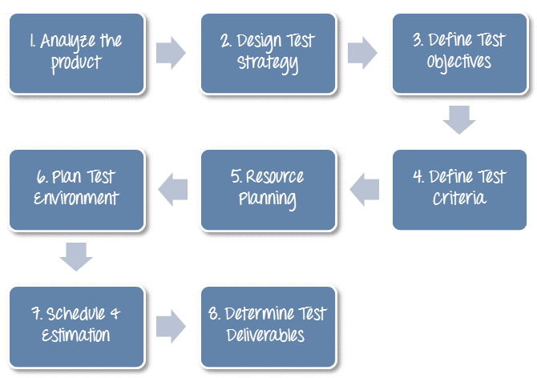](https://www.guru99.com/images/TestManagement/testmanagement_article_2_4_3.png)

**Step 1) Analyze the product**

How can you test a product **without** any information about it? The answer is **Impossible.**You must learn a product **thoroughly**before testing it.

The product under test is Guru99 banking website. You should research clients and the end users to know their needs and expectations from the application

* Who will use the website?
* What is it used for?
* How will it work?
* What are software/ hardware the product uses?

You can use the following approach to analyze the site

[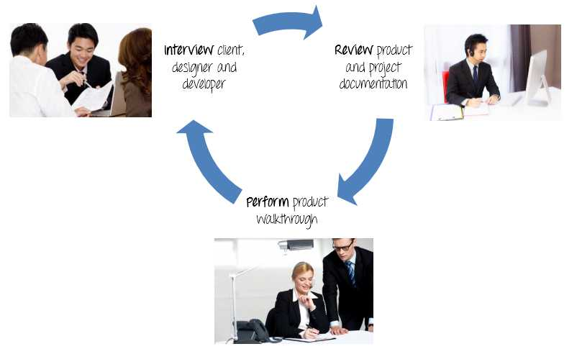](https://www.guru99.com/images/TestManagement/testmanagement_article_2_4_4.jpg)

**Step 2) Develop Test Strategy**

Test Strategy is a **critical step**in making a Test Plan in Software Testing. A Test Strategy document, is a high-level document, which is usually developed by Test Manager. This document defines:

* The project’s **testing objectives** and the means to achieve them.
* Determines testing **effort** and **costs**

You should follow steps below

[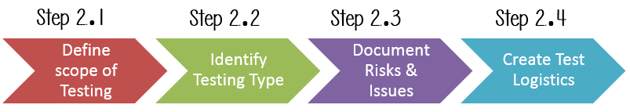](https://www.guru99.com/images/TestManagement/testmanagement_article_2_4_6.png)

**Step 2.1) Define Scope of Testing**

Before the start of any test activity, scope of the testing should be known. You must think hard about it.

* The components of the system to be tested (hardware, software, middleware, etc.) are defined as "**in scope**"
* The components of the system that will not be tested also need to be clearly defined as being "**out of scope**."

Defining the scope of your testing project is very important for all stakeholders. A precise scope helps you

* Give everyone a **confidence & accurate information** of the testing you  are doing
* All project members will have a **clear** understanding about what is tested and what is not

***How do you determine scope your project?***

To determine scope, you must –

* Precise customer requirement
* Project Budget
* Product Specification
* Skills & talent of your test team

Now should clearly define the "in scope" and "out of scope" of the testing.

* As the software requirement [specs](https://docs.google.com/document/d/1rPW5DV82VJT6vtA1VDSrfxaCBuAduxW0zb1yfTh_VMk/edit?pli=1#heading=h.ftgetk7f23qj), the project focus on testing all the **functions** and external interface of website  (**in scope** testing)
* Nonfunctional testing such as **stress**, **performance** or **logical database** currently will not be tested. (**out of** scope)

**Problem Scenario**

The customer wants you to test his API. But the project budget does not permit to do so. In such a case what will you do?

Well, in such case you need to convince the customer that [Api Testing](https://www.guru99.com/api-testing.html) is extra work and will consume significant resources. Give him data supporting your facts. Tell him if Api Testing is included in-scope the budget will increase by XYZ amount.

The customer agrees and accordingly the new scopes, out of scope items are

* In-scope items:[Functional Testing](https://www.guru99.com/functional-testing.html), Api Testing
* Out of scope items: [Database Testing](https://www.guru99.com/data-testing.html), hardware & any other external interfaces

**Step 2.2) Identify Testing Type**

A **Testing Type** is a standard test procedure that gives an expected test outcome.

Each testing type is formulated to identify a specific type of product bugs. But, all Testing Types are aimed at achieving one common goal “**Early detection of** all the defects before releasing the product to the customer”

The **commonly used** testing types are described as following figure

[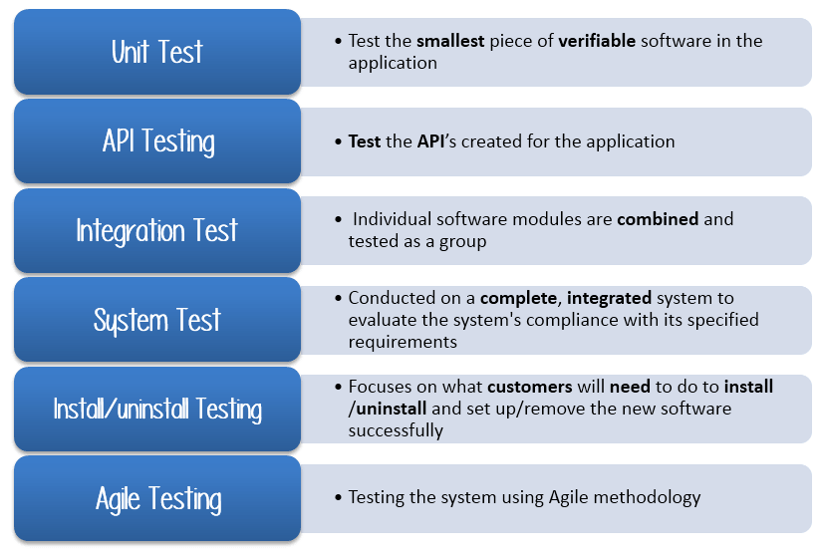](https://www.guru99.com/images/TestManagement/testmanagement_article_2_4_7.png)Commonly Used Testing Types

There are **tons of Testing Types** for testing software product. Your team **cannot have** enough efforts to handle all kind of testing. As Test Manager, you must set **priority** of the Testing Types

* Which Testing Types should be **focused** for web application testing?
* Which Testing Types should be **ignored** for saving cost?

**Step 2.3) Document Risk & Issues**

Risk is future’s **uncertain event** with a probability of **occurrence** and a **potential** for loss. When the risk actually happens, it becomes the ‘**issue’.**

In the QA Test Plan, you will document those risks

|  |  |
| --- | --- |
| **Risk** | **Mitigation** |
| Team member lack the required skills for website testing. | Plan **training course** to skill up your members |
| The project schedule is too tight; it's hard to complete this project on time | Set **Test Priority** for each of the test activity. |
| Test Manager has poor management skill | Plan **leadership training** for manager |
| A lack of cooperation negatively affects your employees' productivity | **Encourage**each team member in his task, **and inspire** them to greater efforts. |
| Wrong budget estimate and cost overruns | Establish the **scope** before beginning work, pay a lot of attention to project planning and constantly track and measure the progress |

**Step 2.4) Create Test Logistics**

 In Test Logistics, the Test Manager should answer the following questions:

* **Who**will test?
* **When**will the test occur?

**Who will test?**

You may not know exact names of the tester who will test, but the **type of tester** can be defined.

To select the right member for specified task, you have to consider if his skill is qualified for the task or not, also estimate the project budget. Selecting wrong member for the task may cause the project to**fail** or **delay**.

Person having the following skills is most ideal for performing software testing:

* Ability to **understand** customers point of view
* Strong **desire** for quality
* **Attention** to detail
* Good **cooperation**

In your project, the member who will take in charge for the test execution is the **tester.** Base on the project budget, you can choose in-source or outsource member as the tester.

**When will the test occur?**

Test activities must be matched with associated development activities.

You will start to test when you have **all required items** shown in following figure

[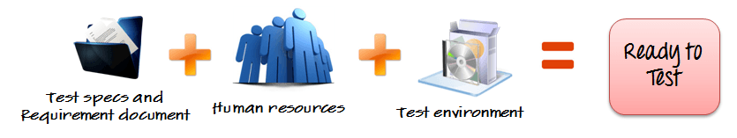](https://www.guru99.com/images/TestManagement/testmanagement_article_2_4_8.png)

**Step 3) Define Test Objective**

Test Objective is the overall goal and achievement of the test execution. The objective of the testing is finding as many software defects as possible; ensure that the software under test is **bug free** before release.

To define the test objectives, you should do 2 following steps

1. List all the software features (functionality, performance, GUI…) which may need to test.
2. Define the **target** or the **goal** of  the test based on  above features

**Step 4) Define Test Criteria**

Test Criteria is a standard or rule on which a test procedure or test judgment can be based. There’re 2 types of test criteria as following

**Suspension Criteria**

Specify the critical suspension criteria for a test. If the suspension criteria are met during testing, the active test cycle will be **suspended** until the criteria are **resolved**.

Test Plan Example: If your team members report that there are **40%** of test cases failed, you should **suspend** testing until the development team fixes all the failed cases.

[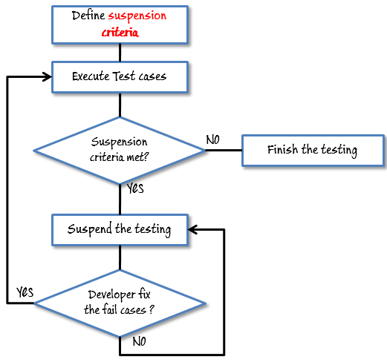](https://www.guru99.com/images/TestManagement/testmanagement_article_2_4_10.png)

**Exit Criteria**

It specifies the criteria that denote a **successful** completion of a test phase. The exit criteria are the targeted results of the test and are necessary before proceeding to the next phase of development. Example: **95%** of all critical test cases must pass.

Some methods of defining exit criteria are by specifying a targeted **run rate** and **pass rate**.

* Run rate is ratio between **number test cases executed/total test cases** of test specification. For example, the test specification has total 120 TCs, but the tester only executed 100 TCs, So the run rate is 100/120 = 0.83 (83%)
* Pass rate is ratio between **numbers test cases passed / test cases executed**. For example, in above 100 TCs executed, there’re 80 TCs that passed, so the pass rate is 80/100 = 0.8 (80%)

This data can be retrieved in Test Metric documents.

* **Run** rate is mandatory to be **100%**unless a clear reason is given.
* **Pass** rate is dependent on project scope, but **achieving high pass rate** is a goal.

**Test Plan Example:** Your Team has already done the test executions. They report the test result to you, and they want you to confirm the **Exit Criteria.**

[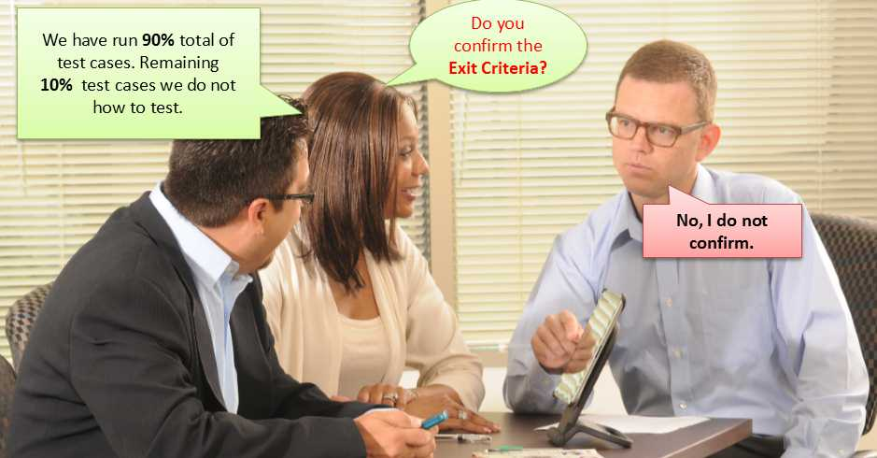](https://www.guru99.com/images/TestManagement/testmanagement_article_2_4_11.jpg)

In above case, the Run rate is mandatory is **100%,**but the test team only completed 90% of test cases. It means the Run rate is not satisfied, so do NOT confirm the Exit Criteria

**Step 5) Resource Planning**

Resource plan is a **detailed summary** of all types of resources required to complete project task. Resource could be human, equipment and materials needed to complete a project

The resource planning is important factor of the test planning because helps in **determining** the **number** of resources (employee, equipment…) to be used for the project. Therefore, the Test Manager can make the correct schedule & estimation for the project.

This section represents the recommended resources for your project.

**Human Resource**

The following table represents various members in your project team

|  |  |  |
| --- | --- | --- |
| **No.** | **Member** | **Tasks** |
| **1.** | Test Manager | **Manage** the whole project  Define project **directions**  Acquire appropriate resources |
| **2.** | Tester | Identifying and describing appropriate test techniques/tools/automation architecture  Verify and assess the Test Approach  **Execute** the tests, **Log** results, **Report** the defects.  Tester could be in-sourced or out-sourced members, base on the project budget  For the task which required **low** skill, I recommend you choose **outsourced** members to **save** project cost. |
| **3.** | Developer in Test | **Implement**the test cases, test program, test suite etc. |
| **4.** | Test Administrator | Builds up and ensures[Test Environment](https://www.guru99.com/test-environment-software-testing.html)and assets are **managed** and **maintained**  **Support**Tester to use the test environment for test execution |
| **5.** | SQA members | Take in charge of quality assurance  Check  to confirm whether the testing process is meeting specified requirements |

**System Resource**

For testing, a web application, you should plan the resources as following tables:

|  |  |  |
| --- | --- | --- |
| **No.** | **Resources** | **Descriptions** |
| **1.** | Server | Install the web application under test  This includes a separate web server, database server, and application server if applicable |
| **2.** | Test tool | The testing tool is to automate the testing, simulate the user operation, generate the test results  There are tons of test tools you can use for this project such as Selenium, QTP…etc. |
| **3.** | Network | You need a Network include LAN and Internet to simulate the real business and user environment |
| **4.** | Computer | The PC which users often use to connect the web server |

**Step 6) Plan Test Environment**

**What is the Test Environment**

A testing environment is a setup of software and hardware on which the testing team is going to execute test cases. The test environment consists of **real business** and **user** environment, as well as physical environments, such as server, front end running environment.

**How to setup the Test Environment**

Back to your project, how do you set up **test environment** for this banking website?

To finish this task, you need **a strong cooperation** between Test Team and Development Team

[](https://www.guru99.com/images/TestManagement/testmanagement_article_2_4_12.png)

You should ask the developer some questions to understand the web application under test **clearly**. Here’re some recommended questions. Of course, you can ask the other questions if you need.

* What is the maximum user connection which this website can handle at the same time?
* What are hardware/software requirements to install this website?
* Does the user's computer need any particular setting to browse the website?

**Step 7) Schedule & Estimation**

In the article [Test estimation](https://www.guru99.com/an-expert-view-on-test-estimation.html), you already used some techniques to estimate the effort to complete the project. Now you should include that estimation as well as the schedule to the Test Planning

In the Test Estimation phase, suppose you break out the whole project into small tasks and add the estimation for each task as below

|  |  |  |
| --- | --- | --- |
| **Task** | **Members** | **Estimate effort** |
| **Create the test specification** | Test Designer | 170 man-hour |
| **Perform Test Execution** | Tester, Test Administrator | 80 man-hour |
| **Test Report** | Tester | 10 man-hour |
| **Test Delivery** |  | 20 man-hour |
| **Total** |  | **280 man-hour** |

Then you create the **schedule** to complete these tasks.

Making schedule is a common term in project management. By creating a solid schedule in the Test Planning, the Test Manager can use it as tool for monitoring the project progress, control the cost overruns.

To create the project schedule, the Test Manager needs several types of input as below:

* **Employee and project deadline**: The working days, the project deadline, resource availability are the factors which affected to the schedule
* **Project estimation**:  Base on the estimation, the Test Manager knows how long it takes to complete the project. So he can make the appropriate project schedule
* **Project Risk**: Understanding the risk helps Test Manager add enough extra time to the project schedule to deal with the risks

**Step 8) Test Deliverables**

Test Deliverables is a list of all the documents, tools and other components that has to be developed and maintained in support of the testing effort.

There are different test deliverables at every phase of the software development lifecycle.

[](https://www.guru99.com/images/TestManagement/testmanagement_article_2_4_15.png)

Test deliverables are provided **before** testing phase.

* Test plans document.
* Test cases documents
* Test Design specifications.

Test deliverables are provided **during** the testing

* Test Scripts
* Simulators.
* Test Data
* Test Traceability Matrix
* Error logs and execution logs.

Test deliverables are provided **after** the testing cycles is over.

* **Test Results/reports**
* Defect Report
* Installation/ Test procedures guidelines
* **Release notes**

**DIFFERENCE BETWEEN TEST PLAN AND TEST STRATERGY**

|  |  |
| --- | --- |
| **Test Plan** | **Test Strategy** |
| * A test plan for software project can be defined as a document that defines the scope, objective, approach and emphasis on a software testing effort | * Test strategy is a set of guidelines that explains test design and determines how testing needs to be done |
| * Components of Test plan include- Test plan id, features to be tested, test techniques, testing tasks, features pass or fail criteria, test deliverables, responsibilities, and schedule, etc. | * Components of Test strategy includes- objectives and scope, documentation formats, test processes, team reporting structure, client communication strategy, etc. |
| * Test plan is carried out by a testing manager or lead that describes how to test, when to test, who will test and what to test | * A test strategy is carried out by the project manager. It says what type of technique to follow and which module to test |
| * Test plan narrates about the specification | * Test strategy narrates about the general approaches |
| * Test plan can change | * Test strategy cannot be changed |
| * Test planning is done to determine possible issues and dependencies in order to identify the risks. | * It is a long-term plan of action.You can abstract information that is not project specific and put it into test approach |
| * A test plan exists individually | * In smaller project, test strategy is often found as a section of a test plan |
| * It is defined at project level | * It is set at organization level and can be used by multiple projects |